**Practical 8 : Implement virtualization using Hyper-V.**

Step 1: Open Windows features on or off from setting.

Step 2: Tick the Hypervisor Click OK. Restart the system.

Step 3: Open the Hyper-V Manager

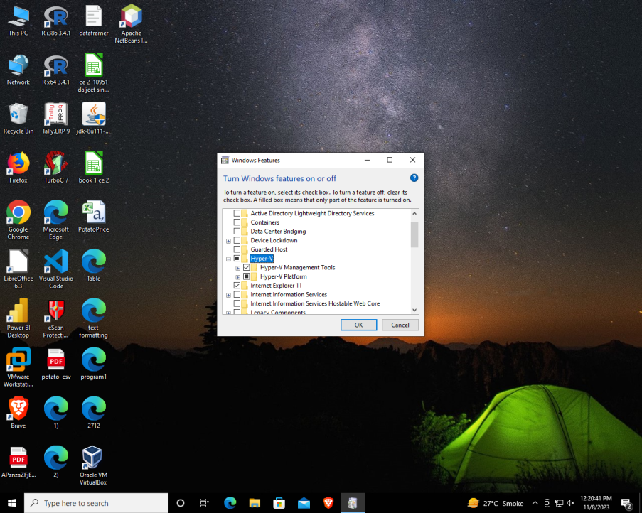

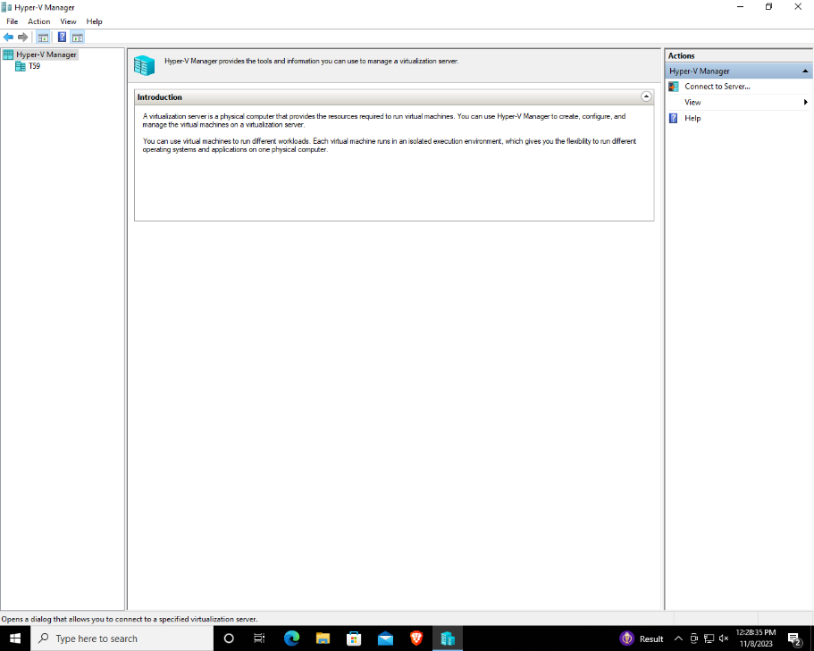

Step 4: Right Click on Hyper-V Manager, Click on Connect to Server…

Step 5: A dialog box will appear, Tick Local Computer and click OK.

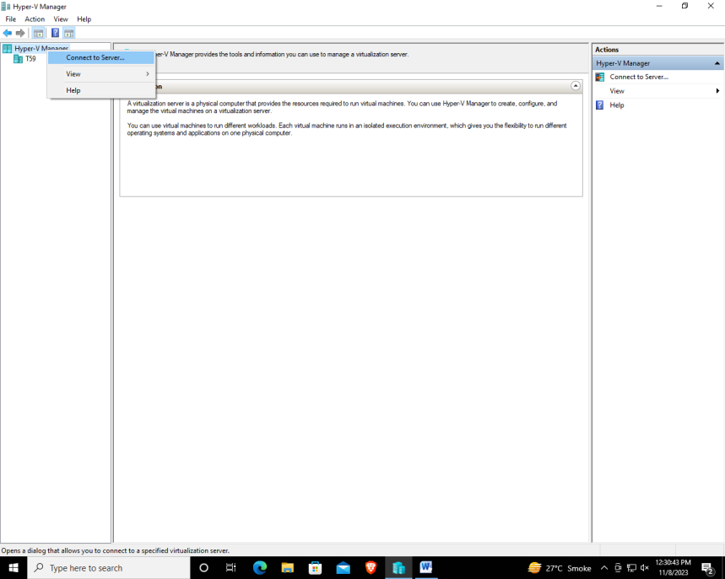

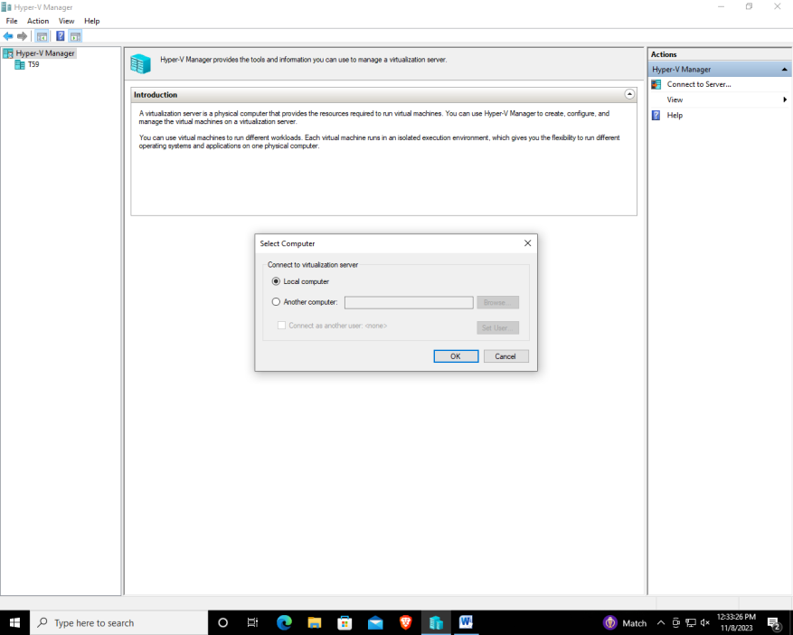

Step 6: Right click on New, click on new Virtual Machine

Step 7: A Dialog box will appear, Click next.

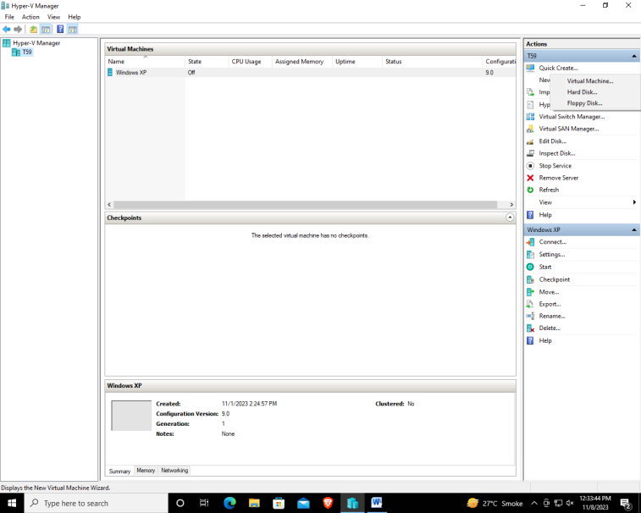

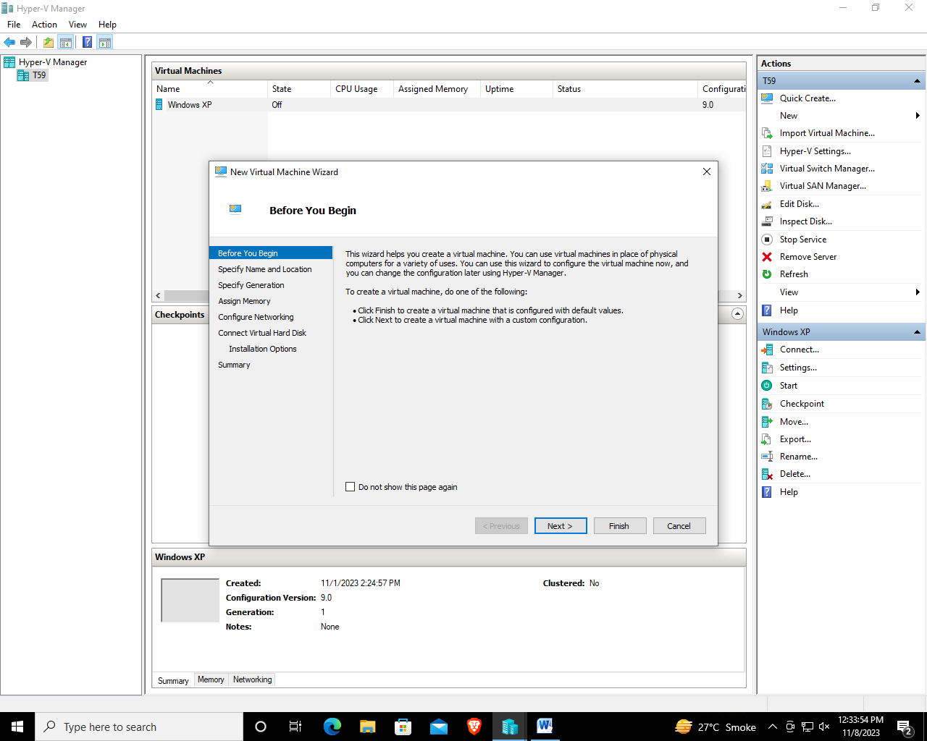

Step 8: Enter the name of virtual machine and click next

Step 9: Tick Generation 1 and click next/

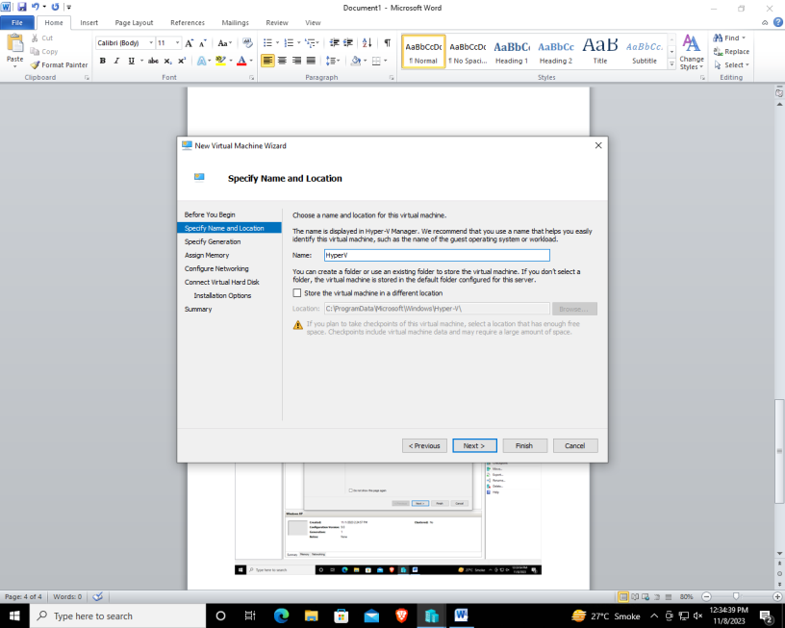

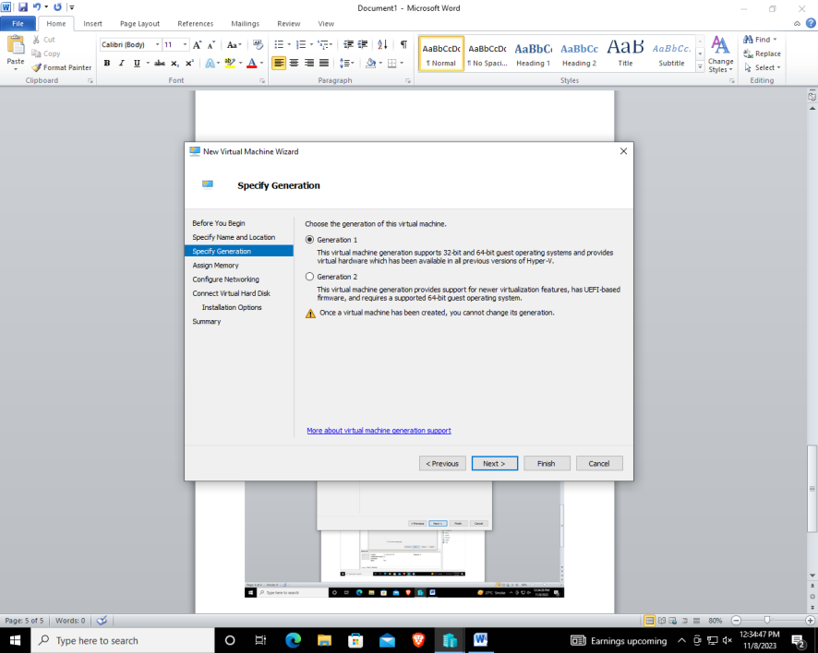

Step 10: Change the memory to 4096 MB and click next

Step 11: Choose connection as Not connected and click next

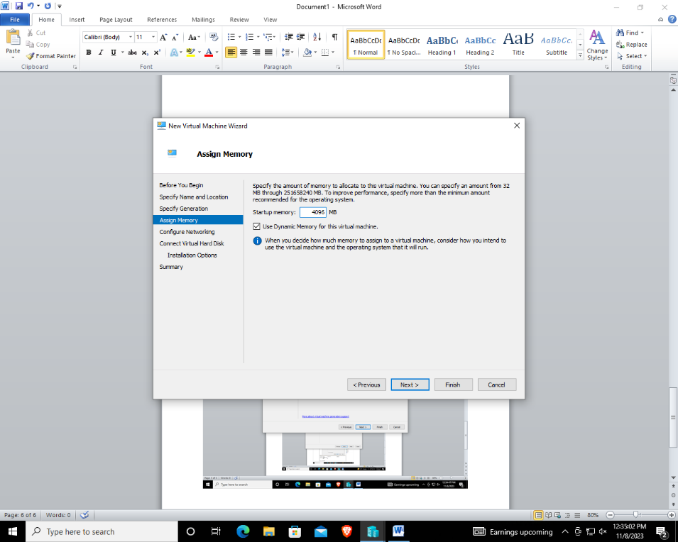

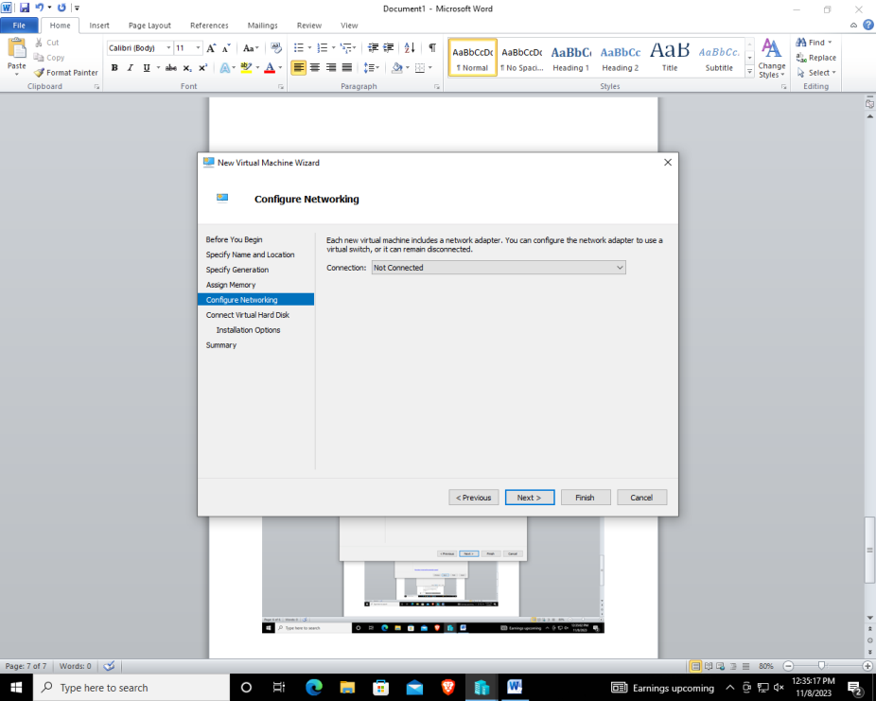

Step 11: Change the size to 60 GB and click next

Step 12: Click on install an operating system later and click next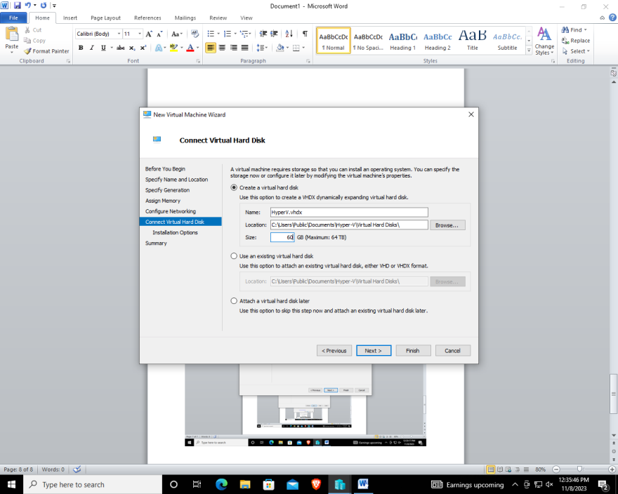

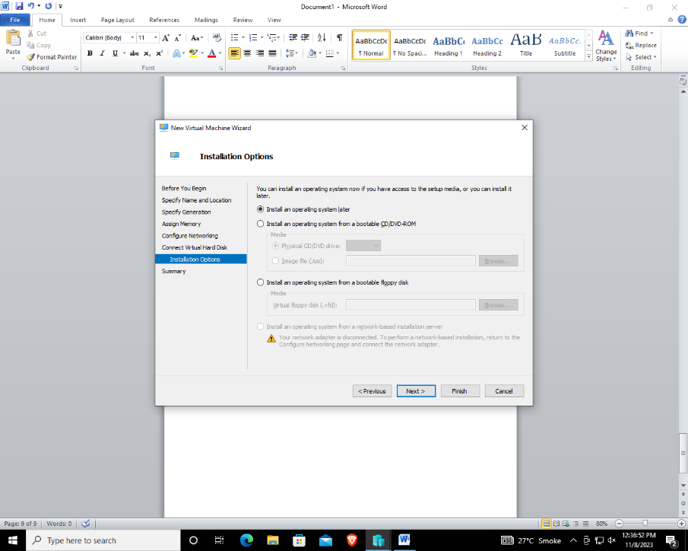

Step 12: You will see dialog box showing the description of the requirements, Click on Finish

